CV

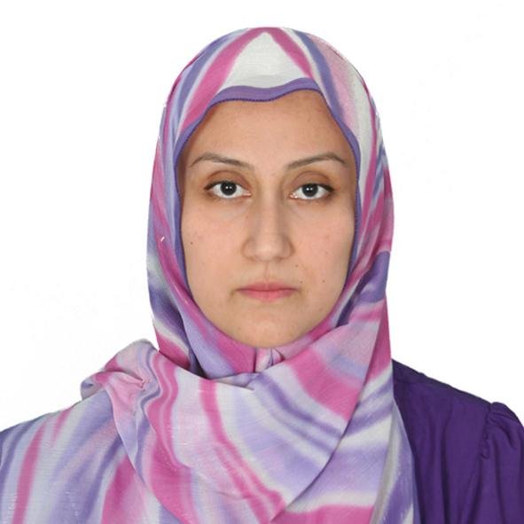
Ulkar Abuzarova
Ph.D in Theology
Home: +994124017762
Mob: +994 55 3065022
abuzarovaulkar@gmail.com

Personal information
Date of birth: 23.07.1975
Nationality: Azerbaijan
Languages: Azerbaijani (native), English (good), Arabic (good), Turkish (excellent), Persian (good).

Work experince
2007-2012 Assistant Professor at Khazar University. Comparative World Religions
2012-2018 Senior Instructor at TDV Baku Turkish School, Arabic Langugage
2018-present Assistant Professor at Azerbaijan Institute of Theology

Education
  - Baku State University, Department of Theology, BA degree (honors) / Major: Theology & Arabic Language Instructor
1999-2001 Marmara University, Institute of Social Sciences, MA degree / Major: Kalam
2001-2005 Marmara University, Institute of Social Sciences, Ph.D degree / Major: Islamic Theology, Kalam.

Researches & Publications
- Abuzarova, U., “Islam in the Light of Hadiths”, TDV, translation of 7th volume from Turkish to Azerbaijani, 2016.

